**WIND TUNNEL TESTING OF CANARD WING AND FABRICATION OF CANARD WING AIRCRAFT MODEL**



**A PROJECT REPORT  
*Submitted by***

**Mr. Sachin. J K (408AN16058)**

***In partial fulfilment for the award of the diploma of***

**DIPLOMA IN AERONAUTICAL ENGINEERING**

**PROGRAMME**



**DEPARTMENT OF AERONAUTICAL ENGINEERING**

**HINDUSTAN ELECTRONICS ACADEMY**

**Department of Technical Education**

**Bangalore-560001**

**Year of Submission (March 2020)**

**A Project Report**

**On**

**WIND TUNNEL TESTING OF CANARD WING AND FABRICATION OF CANARD WING AIRCRAFT MODEL**

Submitted for partial fulfilment of the requirements for the award of the

**DIPLOMA IN AERONAUTICAL ENGINEERING**

**BY**

**Mr. Sachin. J K (408AN16058)**

**Under the guidance of**

**Mr. ANTONY JOSEPH**

Lecturer

Department of Aeronautical Engineering HEA Polytechnic

Bengaluru

**Department of Aeronautical Engineering**

**HINDUSTAN ELECTRONICS ACADEMY**

**#3776, Ashwath Nagar, Marathahalli Post,**

**Bengaluru-560037**

**DEPARTMENT OF TECHNICAL EDUCATION**

**BENGALURU-560001**

**BONAFIDE CERTIFICATE**

Certified that this project report “**WIND TUNNEL TESTING OF CANARD WING AND FABRICATION OF CANARD WING AIRCRAFT MODEL”** is the bona fide work of “SACHIN. JK” who carried out the project work under my supervision.

Mrs. Gayathri Sasikumar Mr. Antony Joseph

**HEAD OF THE DEPARTMENT PROJECT COORDINATOR**

Department of Aeronautical Engineering Department of Aeronautical Engineering

Hindustan Electronics Academy Hindustan Electronics Academy

Ashwathnagar, Marathahalli Ashwathnagar, Marathahalli

Bengaluru-37 Bengaluru-37

**Examiner 1:**

**Examiner 2:**

CANDIDATE’S DECLARATION

I, **SACHIN. JK** student of Diploma in Aeronautical Engineering Department bearing Reg. No 408AN16058 of **HINDUSTAN ELECTRONICS ACADEMY** hereby declare that I own full responsibility for the information, results and conclusions provided in this project work titled “**WIND TUNNEL TESTING OF CANARD WING AND FABRICATION OF CANARD WING AIRCRAFT MODEL”** submitted to **State Board of Technical Examinations, Government of Karnataka** for the award of Diploma in Aeronautical Engineering.

To the best of my knowledge, this project work has not been submitted in part or full elsewhere in any other institution/organization for the award of any certificate/diploma/degree.

I have completely taken care in acknowledging the contribution of others in this academic work.

I further declare that in case of any violation of intellectual property rights and particulars declared, found at any stage, I, as the candidate will be solely responsible for the same.

**Date: 21 OCT 2019**

**Signature of the candidate**

**Place: BANGALORE**

**Name: SACHIN. JK**

**Reg. No: 408AN16058**

**DEPARTMENT OF TECHNICAL EDUCATION**

**HINDUSTAN ELECTRONICS ACADEMY**

P.B No: 3776, Ashwathnagar,

Marathahalli, Bengaluru­-37

Department of Aeronautical Engineering

CERTIFICATE

Certified that this project report entitled “**WIND TUNNEL TESTING OF CANARD WING AND FABRICATION OF CANARD WING AIRCRAFT”** which is beingsubmitted by Mr. SACHIN. JK Reg. No. 408AN16058, abona fide student of HINDUSTAN ELECTRONICS ACADEMY in partial fulfilment for the award of **Diploma in Aeronautical Engineering** during the year 2017-2020 is record ofstudent’s own work carried out under my/our guidance. It is certified that allcorrections/suggestions indicated for internal Assessment have been incorporated in theReport and one copy of it being deposited in the polytechnic library.

The project report has been approved as it satisfies the academic requirements in respect of Project work prescribed for the said diploma.

It is further understood that by this certificate the undersigned do not endorse or approve any statement made, opinion expressed or conclusion drawn there in but approve the project only for the purpose for which it is submitted.

**Guide**

Mr. Antony Joseph

Examiner 1:

**Head of the department**

Examiner 2:

**ABSTRACT**

The term “CANARD WING” is derived and described for its high performance application. It is well known for its applications at higher angles of attack and better performance characteristics. A canard wing is a quite common configuration in all the high-speed aircraft and fighter jets which helps in better maneuvering capabilities, achieving a higher angle of attack and the wing loading is distributed between the main wing and the canard wing. As easy purpose it may seem, the construction is complex and the operation principle needs practical exposure to understand deeply.

The project’s objective is to test the canard wing model in the wind tunnel and interpret the pressure distribution and flow variation along the wing and to fabricate a model of an aircraft model with a canard wing.

The performance characteristics of the fabricated canard wing is interpreted with the help of the wind tunnel testing at subsonic speed. The canard wing is located in front of the main wing to provide longitudinal stability and control.

The problem of flow separation at higher angles of attack and the increased drag will be sorted out by placing an additional wing in front of the main wing which has to be 20-30% of the main wing area.

**ACKNOWLEDGEMENT**

The success and final outcome of this project required a guidance and assistance from many people and we are extremely privileged to have got this all along the completion of our project. All that we have done is only due to such supervision and assistance and we would not forget to thank them.

We express our first and foremost thanks to **Mr. Ram Krishna Reddy** the Principal of **Hindustan Electronics Academy** for extending his support and guidance which made us to complete the project on time we extremely grateful to him for providing such a nice support and guidance though he had busy schedule managing the college affairs.

We owe our deep gratitude to our project guide **Mr. Antony Joseph,** who took keen interest on our project work and guided us all along, till the completion of our project work by providing all the necessary information for developing a good system.

We are thankful to and fortunate enough to get constant encouragement, support and guidance from all teaching staffs of **Department of Aeronautical Engineering** which helped us in successfully completing our project work. Also, we would like to extend our sincere esteems to all Workshop staff for their timely support.

**Mr. SACHIN. J K (408AN16058**

**Contents**

CHAPTER 1

INTRODUCTION…………………………………………………….. 1

* 1. Canard wing…………………………………………………….....1
  2. Types of canard wing configuration……………………………... 2
  3. Pros and Cons of the Canard Configuration……………………....3
  4. Wind tunnel testing……………………………………..................3
  5. Karunya wind tunnel specification………………………………..5
  6. Parts of the wind tunnel…………………………………………...6
  7. Applications………………………………………………..……..7

CHAPTER 2

REVIEW OF LITERATURE…………………………………………...8

2.1 Development of the title ………………………………………....8

2.2 Planning…………………………………………………………..8

2.3 Prototype…………………………………………………………10

2.4 Review…………………………………………………………...10

CHAPTER 3

STUDY AREA…………………………………………………………..10

3.1 Problem definition……………………………………………….10

CHAPTER 4

METHODOLOGY/DESIGN/FABRICATION/TESTING……………...12

4.1 Calculation of location of pressure ports…………………………13

4.2 CATIA V5………………………………………………………..16

4.3 XFLR5……………………………………………………………20

4.4 3D printing……………………………………………………….23

4.5 Wind tunnel testing of the wing…………………………………26

4.6 Flow visualization over the wing……………………………..….29

4.7 Calculation of various parameters………………………………...31

4.8 Comparison of experimental values with the practical values……32

4.9 Fabrication of the canard wing aircraft model…………………….32

CHAPTER 5

RESULT, CONCLUSION AND SCOPE OF STUDY……………………34

5.1 Result………………………………………………………………34

5.2 Conclusion…………………………………………………………34

5.3 Scope of study……………………………………………………..35

REFERENCE……………………………………………………………...36

**LIST OF FIGURES**

Figure 1: Canard wing configuration of a typical aircraft……………………… …1

Figure 2. Lifting canard configuration………………………………………………2

Figure 3: Pitch control canard…………………………………………………….... 2

Figure 4: Wind tunnel specification……………………………………………….. 5

Figure 5: Wind tunnel used for the project (KARUNYA UNIVERSITY)………….5

Figure 6: Fabricated 3D printed model of the wing…………………………….......10

Figure 7: Flow separation in the wing at higher angles of attack…………………..12

Figure 7.1 Effect of canard wing on the flow over the aircraft……………………..12

Figure 8: Location of pressure ports over the wing………………………………....13

Figure 9: 2D model designed in CATIA…………………………………………….15

Figure 10: Finished CATIA model of the canard wing…………………………..…17

Figure 11: Coefficient of lift vs angle of attack (Cl vs α) graph…………………….17

Figure 12: graph…………………………………………………………....18

Figure 13: Cl /Cd vs alpha graph…………………………………………..…………18

Figure 14: Flow analysis over the wing………………………………………….....19

Figure 15: Local lift vs angle of attack of the wing…………………………………19

Figure 16: Cl vs angle of attack of the wing…………………………………………19

Figure 17: Local drag vs angle of attack of the wing………………………………..19

Figure 18: Formation of the wing with the gridlines………………………………..20

Figure 19: The fabricated canard model……………………………………………..20

Figure 20: Fused Deposition Modelling………………………………………….....22

Figure 21: U-Tube manometer……………………………………………………....25

Figure 22: Smoke generators…………………………………………………….….26

Figure 23: Placed wing model in the tunnel with laser……………………………..27

Figure 24: Flow over the wing at 4o………………………………………………....27

Figure 25: Flow over the wing at 14o………………………………………………...28

Figure 26: Flow over the wing at -4o………………………………………………28

**CHAPTER 1**

**INTRODUCTION**

* 1. **Canard wing**

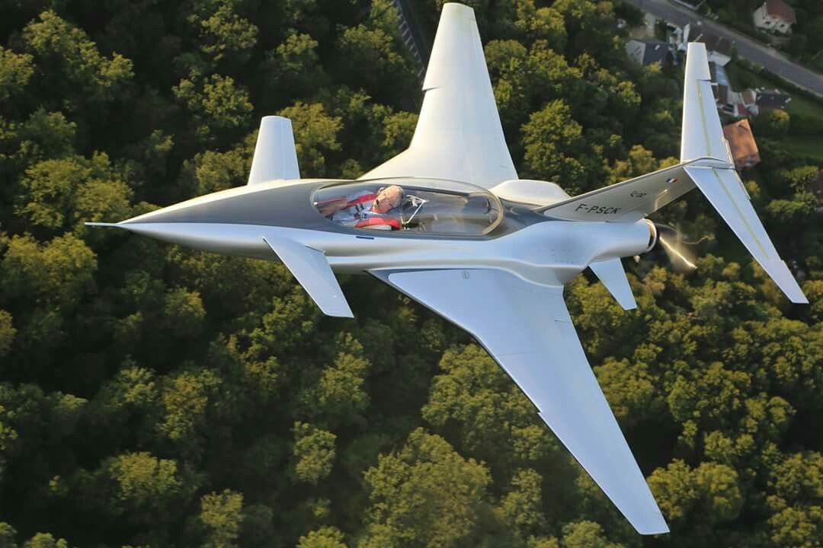

Figure 1: Canard wing configuration of a typical aircraft

A canard is an arrangement of an aircraft wherein a small forewing or a foreplane is placed forward of the main wing of a fixed-wing aircraft. Rather than the use of the conventional tailplane configuration found on most aircraft, a canard configuration can be adopted to reduce the main wing loading, to achieve better control of the main wing airflow, or to increase the maneuverability of the aircraft, especially at higher angles of attack or during a condition of a stall. Canard fore planes have important consequences on the longitudinal equilibrium, static and dynamic stability characteristics of the aircraft.

A canard foreplane may be used for various reasons such as lift, stability, trim, flight control or to modify the airflow over the main wing.

**1.2 Types of Canard Wing Configuration**

1. In the lifting-canard configuration, the weight of the aircraft is shared between the wing and the canard. A lifting canard generates an upload, in contrast to a conventional aft-tail which sometimes generates negative lift that must be counteracted by extra lift on the main wing.

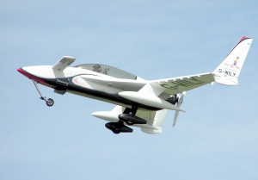

Figure 2. Lifting canard configuration

2. Pitch control in a canard can be achieved either by the canard surface, as on the control-canard or in the same way as a tailless aircraft, by control surfaces at the rear of the main wing. In this most of the weight of the aircraft is carried by the wing and the canard is used primarily for pitch control during maneuvering.

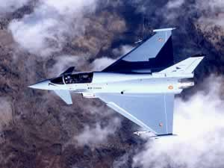

Figure 3: Pitch control canard

3. A canard foreplane can be used as a horizontal stabilizer in which the stability is achieved statically.

**1.3** **Pros and Cons of the Canard Configuration**

Placement of a canard improves the possibility of an aircraft to operate at higher angles of attack and better maneuvering capabilities. A horizontal lifting surface placed forward of the main wing results in a destabilizing pitching moment, which would render the aircraft unstable were it is not for the forward placement in the center of gravity.

The center of gravity must be placed far forward of the aerodynamic center of the geometric chord to produce a stabilizing moment. This renders the aircraft stable. Another issue is that the chord length of the canard is usually small enough to be subjected to Reynolds number effects. One of the consequences can be a diminished pitch authority at low airspeed when the small-chord airfoil is subject to early flow separation that reduces the lift curve slope.

**1.4 Wind tunnel testing**

A wind tunnel is a tool used in aerodynamic research to study the effects of air moving past solid objects. A wind tunnel consists of a tubular passage with the object under test mounted in the middle. Air is made to move past the object by a powerful fan system or other means. The test object, often called a wind tunnel model is instrumented with suitable sensors to measure aerodynamic forces, pressure distribution, or other aerodynamic-related characteristics.

Airfoil performance at low Reynolds numbers impacts the performance of a wide range of systems. Low Reynolds number aerodynamics of airfoils apply to a host of other applications such as wind turbines, motorsports, high altitude aircraft and propellers, natural flyers, and subscale testing of many full scale systems.

Wind tunnels are large tubes with air blowing through them. These tunnels are used to replicate the actions of an object flying through the air. Large powerful fans blow air through the tube. The object being tested as held securely and does not move.

The wind tunnel was used for the interpretation of the pressure distribution over the airfoil and thereby the point where the stalling occurs, the highest angle of attack which is possible with the wing without the flow separation. The subsonic wind tunnel was used for our interpretation with the velocity 20m/s.

The wind tunnel was used for the interpretation of the pressure distribution over the airfoil and thereby the point where the stalling occurs, the highest angle of attack which is possible with the wing without the flow separation. The subsonic wind tunnel was used for our interpretation with the velocity 20m/s.

The flow over the wing was visualized with the help of the smoke generators and laser. The point where the flow separates, the formation of the vortex and the flow separation are visualized using the smoke generators and the lasers suction type subsonic wind tunnel is used and a 32 port U-tube manometer is used for interpreting the pressure difference along the airfoil as the air flows through it at different angles of attack.

The wind tunnel will be of either suction or blower type wind tunnel with close section or open section wind tunnel. The wind tunnel which was used for the purpose of the project was a closed section suction type wind tunnel with a maximum velocity capacity of 45m/s.

The object being tested is held securely inside the wind tunnel so that it remains stationary and does not move. The motion of the air can be studied in different ways; smoke or dye can be placed in the air and can be seen as it moves around the object. Colored threads can also be attached to the object to show how the air moves around it. Special instruments can often be used to measure the force of the air exerted over the object.

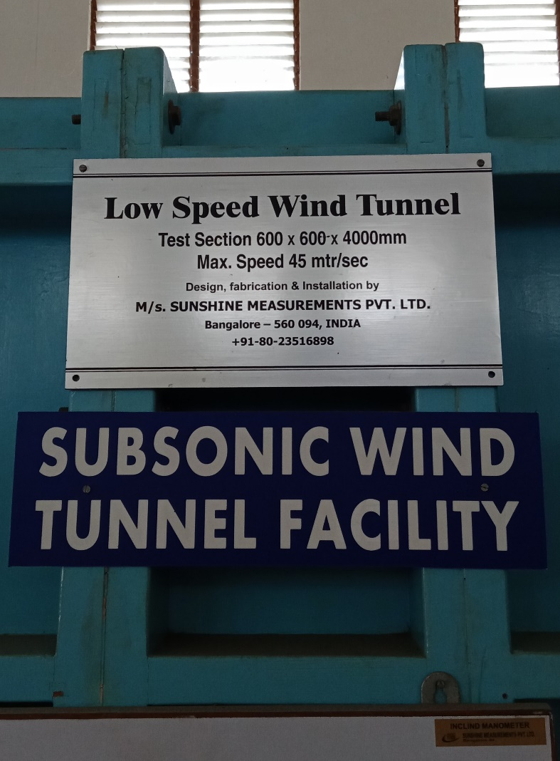

Figure 4: Wind tunnel specification

**1.5 Karunya wind tunnel specification:**

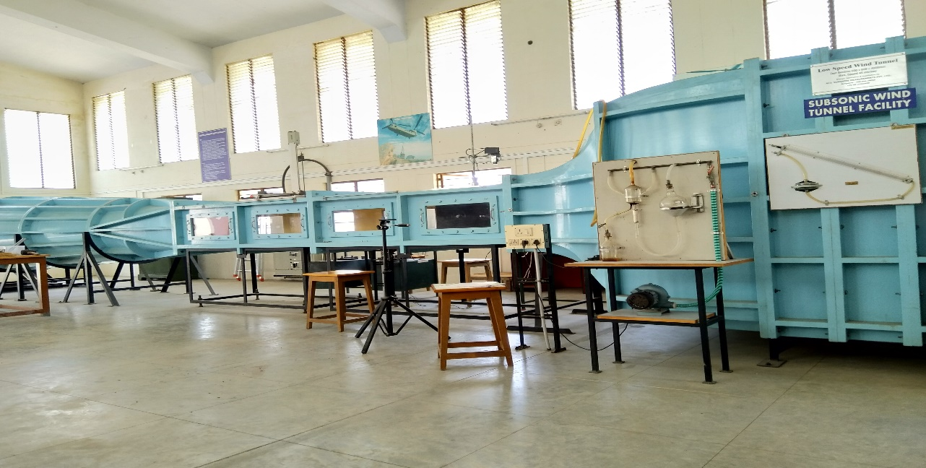

Figure 5: Wind tunnel used for the project (KARUNYA UNIVERSITY)

Type of tunnel : low speed, open circuit suction type

Test section : 600mm x 600mm x 4000mm

Drive : axial flow fan driven by ac motor (7.5 HP) and AC drive for speed

Controlling

Power requirement: AC 3 phase, 440V, 32A electrical supply

Maximum speed : 45 meter/sec

**1.6 Parts of the wind tunnel:**

1. Inlet duct:

The axial and lateral turbulence are reduced and smooth flow of air entering the section is achieved by installing the Honey-combs and screens, for most effectiveness of the air inlet. The ratio of length to cell size of the honey comb is maintained as per the recommended standards. The wire mesh is also fixed to smoothen the flow further. This is particularly useful for obtaining laminar flow. The screen is made removable for possible cleaning. The duct is secured to the test section by flange. The provision is also made for easy removal of the diffuser from the test section when required.

1. Test section:

The central position of the test section is sandwiched between the inlet duct and the diffuser using flange. It has 600mm x 600mm cross section and 4000mm length. Fixed with transparent window on either side which facilitates fixing and viewing if the models. This houses smoke chest fixing points. The traversing mechanism is fixed on its top on the movement of total pressure probe. The holes provided for holding the models for different studies and for taping out the pressure probes.

1. Diffuser:

The downstream portion of the tunnel is the diffuser. To the end of this is attached an axial flow fan. The diffuser starts with 400mm x 400mm square section at the test section end and enlarges to 900mm diameter round at the fan driven end. It is flanged and bolted to the test section.

1. Axial flow fan unit:

The fan unit is independent standalone type and does not require any foundation. It is housed in rounded casing which is secured to the diffuser. The bladed rotor is connected to AC motor directly coupled.

**1.7 Applications:**

In most of the applications, modern aircrafts adapt the canard wing configuration. It is one of the oldest configuration employed in the design of the aircraft but still have a lot of scope because of its application at high speed flights and higher angles of attack.

Since canard wing gives far better performance characteristics than a conventional design because of its parameters and the better wing loading, it is used in most of the high speed fighter jets.

The canard wing is implemented in most of the fighter aircrafts and supersonic jets because of its maneuvering performance characteristics at higher angles of attack. The distribution of wing loading being in between the canard wing and the main wing makes it easier for operation and control. Better stability is obtained in the canard wing configuration thus making it more suitable for fighter jet applications.

The wind tunnel is used for interpreting the performance characteristics of the object tested such as the flow variations over the object and reducing the cost involved in testing the object in reality by testing it under simulating the conditions inside a closed tunnel and obtaining the real condition parameters of the object.

**CHAPTER 2**

**REVIEW OF LITERATURE**

**2.1 Development of the title:**

After studying and reviewing many ideas and concepts during the early semesters and the need for matching the academic standards had all its influence on fixing the project.

To meet the standards of curriculum and to have an easy yet illustrative model canard wing was selected as area of study. It was thought a wind tunnel testing of a canard wing and a fabrication of a model of canard wing aircraft would be most promising.

Most of the fighter jets and supersonics jets nowadays adapt canard wing in their configuration that is used for better performance characteristics. So it was decided to make the canard wing and the wind tunnel testing of the same, so that it can be understood more conceptually.

Hence the project “WIND TUNNEL TESTING OF A CANARD WING AND MODEL OF A CANARD WING AIRCRAFT” was originated.

The entire aircraft model is too complex to construct and test the complete model in the wind tunnel. Hence it was feasible to construct only the canard wing for the interpretation of the flow in the wind tunnel.

**2.2 Planning:**

The entire project was planned to execute as three major parts:

* Development and analysis of the model in software:

The model of the canard wing was developed with the help of CATIA V5 with a hollow sectioned wing with a thickness of 3mm and a chord length of 230mm and root chord and tip chord of 147mm and 98mm respectively and the modelled canard wing was analyzed with the real simulating conditions with the help of XFLR5- an analysis tool for obtaining the lift and drag values and the flow over the wing theoretically.

The values obtained from the analysis will be compared with the values which are obtained with the wind tunnel testing and hence the difference between the theoretical and practical experimental values can be interpreted.

* Fabrication of the canard wing:

The canard wing which was designed and analyzed with the help of CATIA V5 and XFLR5 is fabricated according to the dimensions calculated along with the pressure ports which is vital for the measurement of pressure distribution along the wing during the wind tunnel testing. The fabrication of the canard wing was done with the 3d printing with the Fused Deposition Method (FDM) using the Acrylonitrile Butadiene Styrene (ABS) which is a thermoplastic polymer material.

* Wind tunnel testing of the canard wing:

The fabricated canard wing was tested in the subsonic tunnel of a suction type open circuit with a velocity of 20m/s. The variation of the airflow over the wing at various angles of attack was visualized with the help of smoke generators and the lasers. The pressure variation along the wing was interpreted with the pressure ports available in the wing. The pressure ports were connected to the U-tube manometer for calculating the pressure exerted at the respective pressure ports.

* Interpretation of the results:

The pressure values which were obtained from the U-tube manometer of the wind tunnel at various angles of attack, the lift, drag, maximum coefficient of lift, stalling angle of attack, aerodynamic center and the various graphs such as coefficient of lift vs alpha, coefficient of drag vs alpha and coefficient of lift vs coefficient of drag and their relations were calculated and plotted.

* Fabrication of an aircraft model:

The main dimensions were scaled down to 50% and the model was fabricated with the help of depron and vinyl sheets for covering. The airfoil NACA 2412 was used with a taper ratio of 1.5. This model was fabricated just to show how our canard wing will be placed and for us to understand the designing of an aircraft.

**2.3 Prototype:**

After going through a lot of pieces of literature, it was found that the performance characteristics and flow patterns of the canard wing were hard to imagine theoretically and a prototype was made to understand the actual working and practical deviation from the theoretically calculated values.

The prototype of the wing which has to be tested was made using the acrylonitrile butadiene styrene and the aircraft model was made using depron. The prototype helped in understanding the proper orientation of the components.

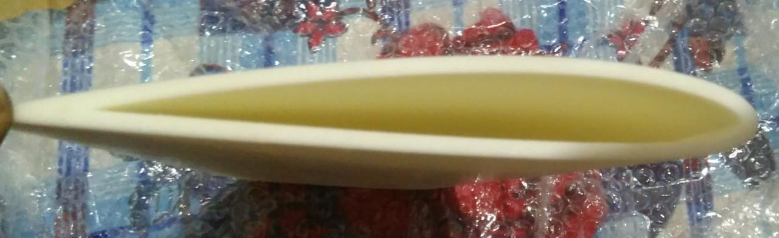

Figure 6: Fabricated 3D printed model of the wing

**2.4 Review:**

There were a lot of resources used to get this idea and not to mention any specific book, paper, article or any other papers that gave rise to the idea, it was all studied in previous semesters and kept on developing as required.

**CHAPTER 3**

**STUDY AREA**

The conventional airplane design has a disadvantage of less maneuvering capability and the constrains in achieving higher angles of attack because of the flow separation which occurs at higher angles of attack. Hence an additional wing is placed in front of the main wing to compensate with the flow separation. However, the canard wings are ineffective at subsonic speeds and create more drag and hence this configuration is not adopted for subsonic and commercial aircraft. But because of the requirement of the higher angles of attack and frequent maneuvers the canard is used in most of the military aircraft which operate at supersonic speeds.

The flow characteristics of the canard wing such as the pressure distribution over the wing are calculated with the aid of the wind tunnel testing. The graph of the Cl vs alpha is plotted and the lift and drag which is obtained from the wing are calculated. The flow pattern over the wing is interpreted. A model of an aircraft with the canard is fabricated with the area being 31% of the main wing area.

* Flow visualization over the canard wing:

The flow visualization over the canard wing is interpreted by using the smoke generators and the laser. A more accurate way to visualize free stream flow is to use smoke or laser sheets. The assumption is made that the smoke or seed particles for the laser more exactly with the flow and therefore gives some indication of how the flow moves around the model.

Using a custom made smoke generator and probe, a stream of white smoke can be inserted anywhere in the test section by positioning the probe using the transverse rig or by hand.

* Pressure distribution over the canard wing:

The distribution of pressure over the wing is calculated by placing the pressure ports at predetermined values. The distribution of pressure coefficient integrated along the airfoil contour yields the lift and drag coefficient. By integration the surface pressure coefficient distribution, one can obtain the lift, pressure drag and pitching moment coefficients.

**3.1 Problem definition:**

Most of the aircraft have the problem of achieving the higher angles of attack because of the flow separation which takes place at increased angles of attack and hence affecting the maneuvering capabilities. Hence a canard wing which is an additional wing is placed in front of the main wing to achieve better and quick maneuvers which are the prime requisite for a fighter jet. The angle at which the stalling occurs is vital while designing an aircraft or a wing because beyond that point the aircraft will be no more suitable to provide the required lift. Hence it has to determine with the help of analysis and also wind tunnel testing.

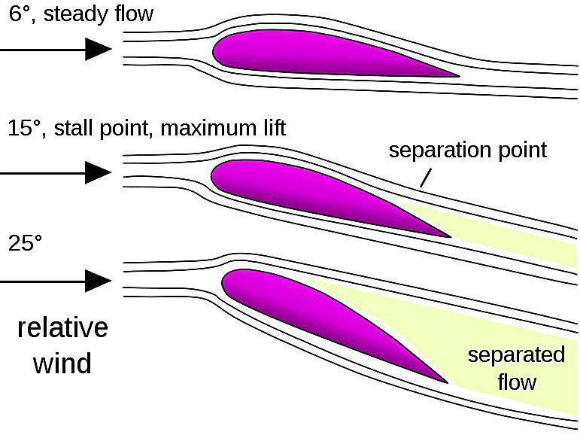

Figure 7: Flow separation in the wing at higher angles of attack

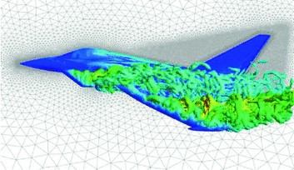

Figure 7.1 Effect of canard wing on the flow over the aircraft

**CHAPTER 4**

**METHODOLOGY/ DESIGN/ FABRICATION/ TESTING**

Setting out from an abstract idea to weeks and weeks of hardworking and planning, the project was designed. Following explains the details of the procedure and the problems faced and the method in which the project was carried out.

**4.1 Calculation of the location of pressure ports:**

The location of the pressure ports is determined by the formula

Location of pressure ports = x/c

Where x is the horizontal coordinate position from origin starting from the leading edge.

c is the mean chord of the wing.

The pressure ports are placed at 50% from the root of the wing for getting accurate results.

|  |  |
| --- | --- |
| X coordinate | x/c |
| 10% | 0.81 |
| 20% | 1.63 |
| 30% | 2.44 |
| 40% | 3.26 |
| 50% | 4.08 |
| 60% | 4.89 |
| 70% | 5.71 |
| 80% | 6.53 |
| 90% | 7.34 |

The wing totally had 28 ports: 10 ports on the top surface and 10 ports on the bottom surface which is calculated with the x/c coordinates and a port at the stagnation point and also four more additional points are added at the leading edge of the wing and hence the location of the pressure ports are determined.

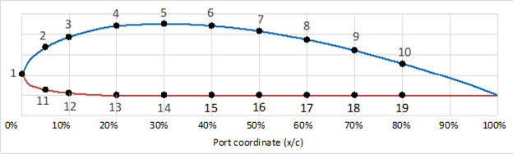

Figure 8: Location of pressure ports over the wing

* 1. **CATIA V5:**

Initially, the model was designed with CAD software, but because of the requirement of the 3d model of the canard wing, the CATIA software was picked.

Initially the model of the wing to be used for wind tunnel testing is designed using CATIA V5. The model of the wing was designed as a hollow section with an airfoil series of NACA 2412 with a thickness of 3mm along with the pressure ports. The pressure ports were predetermined.

The tool designed on CATIA V5 creates in three steps the surface of the wing dimensioning. Firstly, the value tables in the text file exported from the airfoil tools are imported in CATIA V5. From those values, the airfoil coordinates at the wing root and tip are extrapolated and the wing span is determined.

Then sketches of the airfoils are created at the wing root and tip and another sketch is created as a guide curve for the surface grid. The guide curve is essential to the creation of the wing, it links the trailing edge point at the root of the wing and the corresponding trailing edge point at the tip of the wing.

Lastly, the volume is created from the previous sketches and a wing shell is created as an outer surface. Once the wing surface is created, the pressure coordinates are determined on each cell of the surface of the wing according to the distribution given by the XFLR5 analysis and the predetermined calculated values.

The extrapolation of the chord coordinates depends on the dihedral angles and wing sweep. When the wing is created the airfoil is modifiable hence optimizable since coordinate parameters were created for each point of the airfoil. The coordinates are dimensionless.

With the aim to enable modifications to the wing chord, an additional parameter corresponding to each airfoil chord was created. Then without importing the coordinates again and without starting over the wing design modifications could be done.

The generation of the wing surface is finalized by the construction of the wing volume and the shell, creating the final surface. The default thickness was 0.0625mm but it was changed to 3mm because of the requirements of the wind tunnel testing. For the wing analysis, the default material applied is aluminium. By knowing that the analysis of constraints does not change significantly with the material used, it is not necessary to change the material of the studied wing.

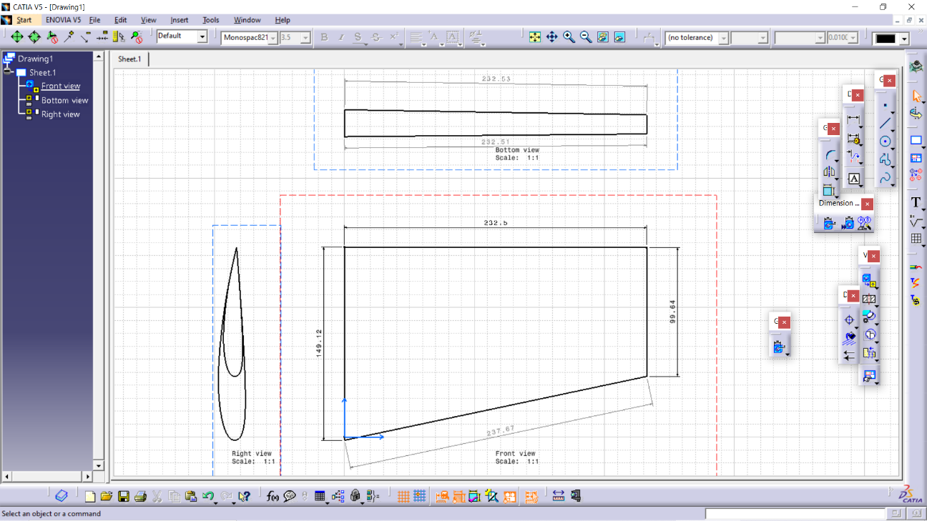

Figure 9: 2D model designed in CATIA

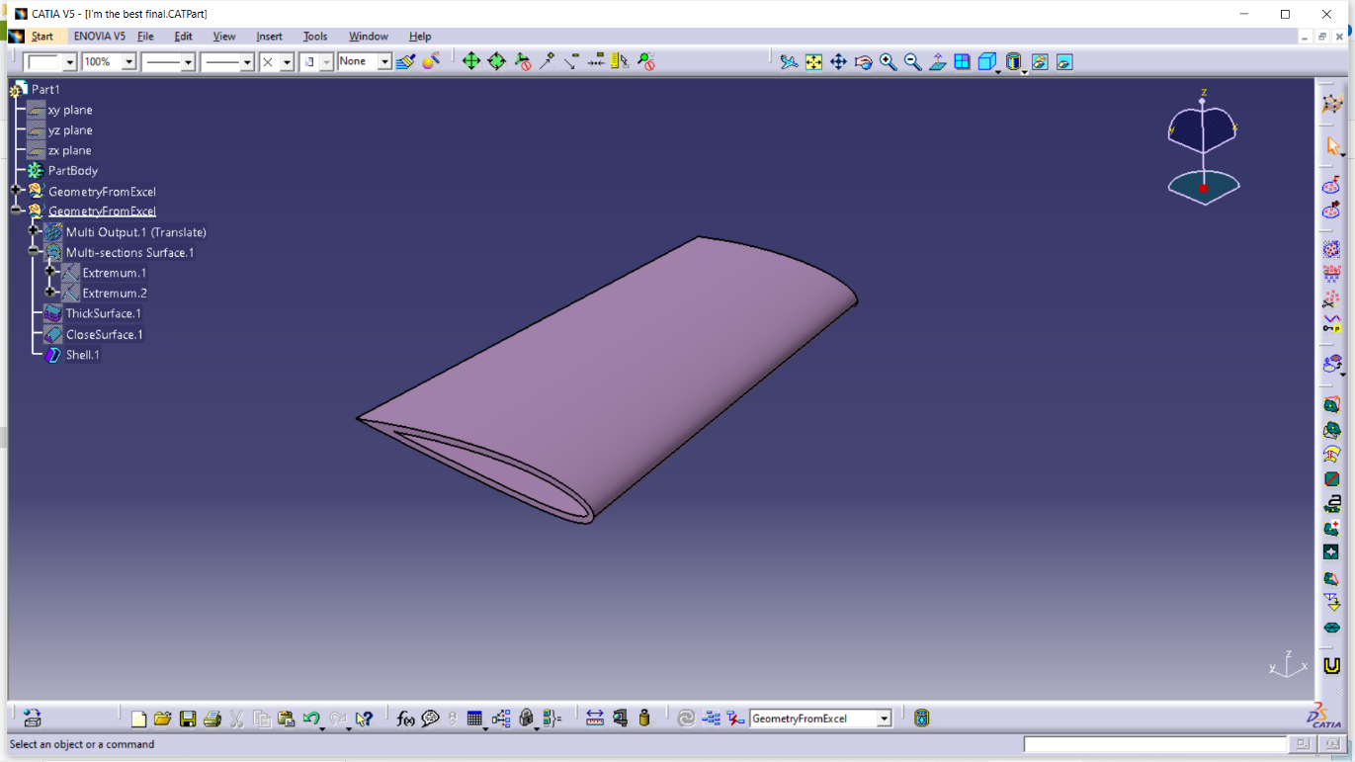

Figure 10: Finished CATIA model of the canard wing

* 1. **XFLR5:**

To achieve reliable results, we will therefore need to combine the software results for its design and structural analysis. Hence XFRL5 was chosen to make the analysis at the given conditions. The XFLR5 software allows quick analysis of the wing based on the analysis of the airfoils used.

The XFLR5 software was used to obtain the theoretical variation of lift, drag with angle of attack. By using the XFLR5 software to compute wing performances, out of the various methods available, 3D panels method was picked. The objective is to obtain an accurate analysis of the aero-structural interactions, where the accuracy of the calculations is very important. In order to compare the obtained results, the variations of the lift, drag coefficients as functions of angle of attack were first numerically traced. The XFLR5 3D panels methodology provided these values for the studied wing.

The 3D panels method consists of meshing the wing surface with panels, and performing aerodynamic calculations on each created panels. To perform the analysis of the wing, we need to import the airfoil coordinates used for its design. In order to import the airfoils from a text file, the file must respect a specific format, which means, that the first line must contain the name of the airfoil, followed by the X and Y coordinates of the airfoil starting their numeration from the trailing edge.

XFLR5 code uses a C++ translation of the XFoil software code to generate performance aerodynamic results which are starting points for airfoil analysis. The calculations used are identical to the XFoil software calculation, but XFRL5 code mainly offers a more evolved and intuitive user interface compared to XFoil code, along with the additional functionalities such as wing analysis and stability analysis.

Wing performance such as lift coefficient with the angle of attack, drag coefficient with angle of attack was interpreted. The 3D panels calculation method computes the aircraft performances based on its geometries. Thus the lift and drag of the wing are obtained. To obtain the induced drag, additional calculations are done based on the performance of the airfoil at different Reynolds number. From that analysis, the performance characteristics of the wing can be obtained.

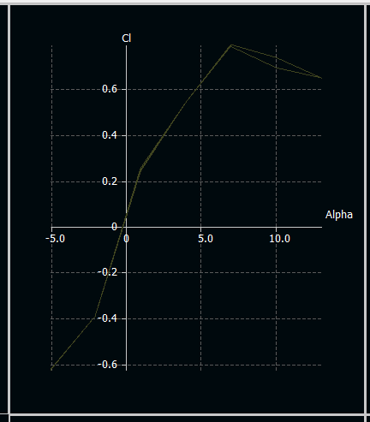

Figure 11: Coefficient of lift vs angle of attack (Cl vs α) graph

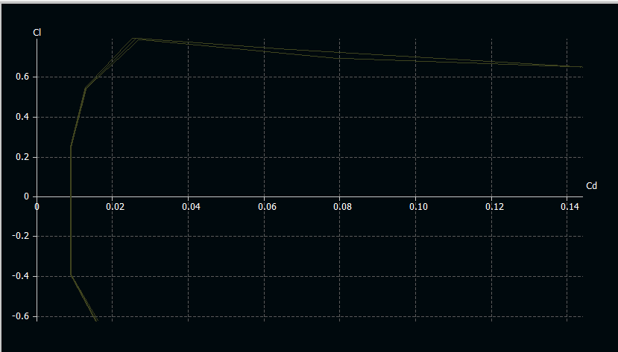

Figure 12: graph

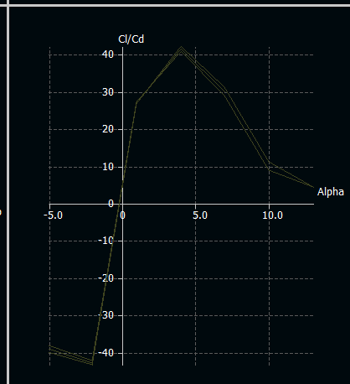

Figure 13: Cl /Cd vs alpha graph

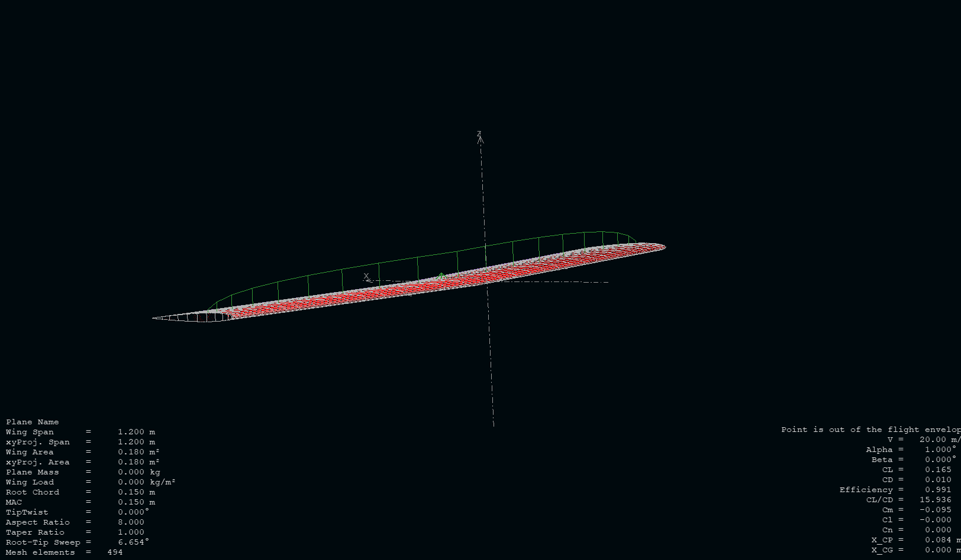

Figure 14: Flow analysis over the wing

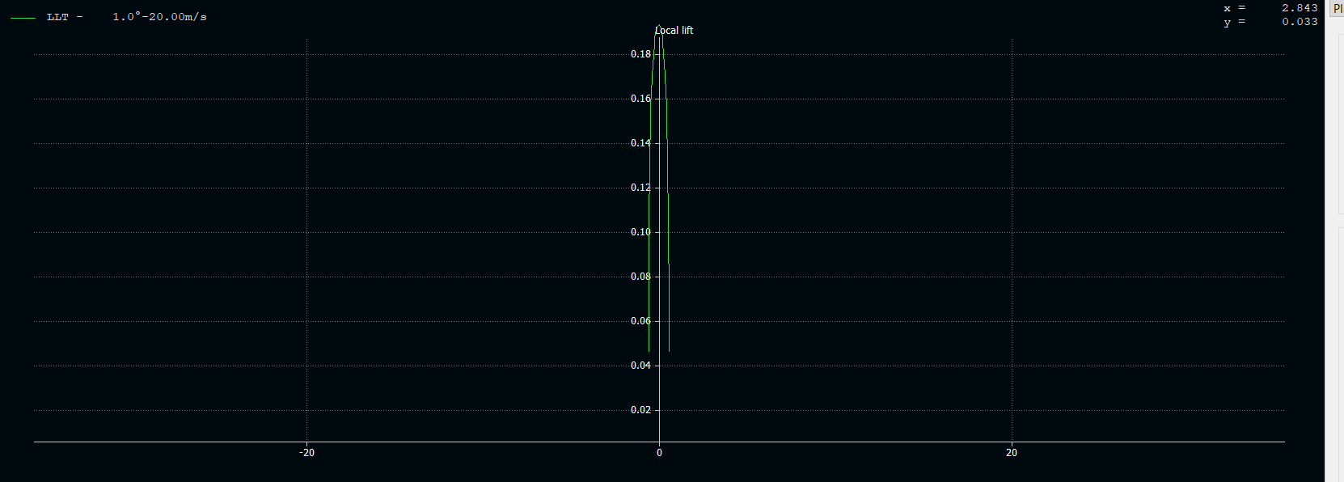

Figure 15: Local lift vs angle of attack of the wing

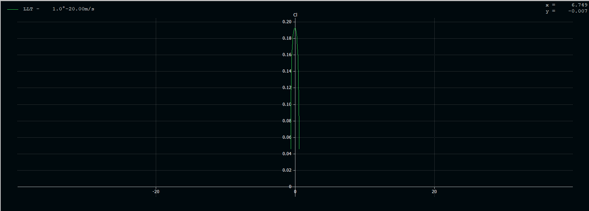

Figure 16: Cl vs angle of attack of the wing

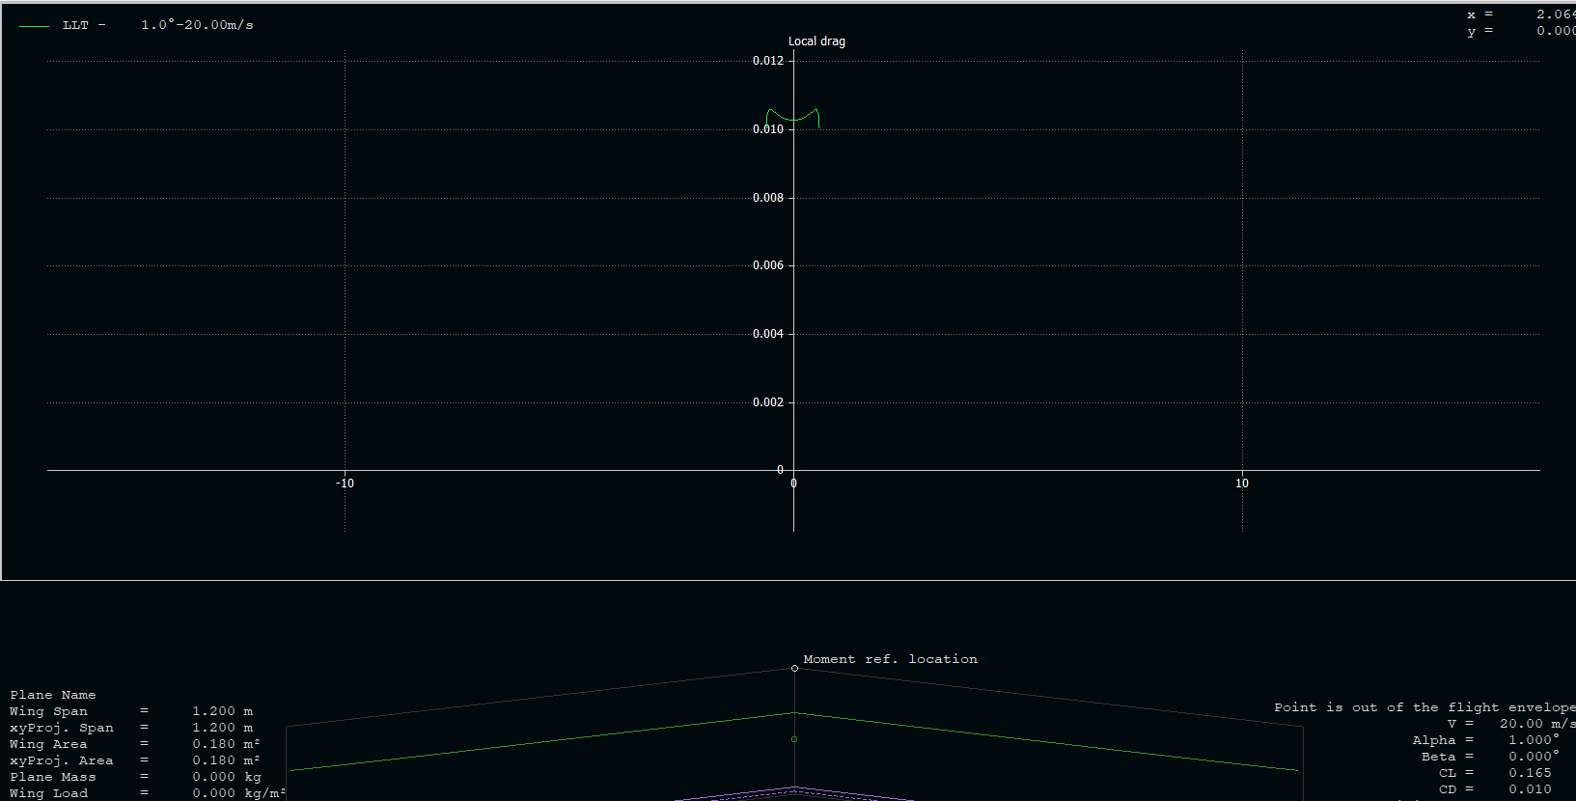

Figure 17: Local drag vs angle of attack of the wing

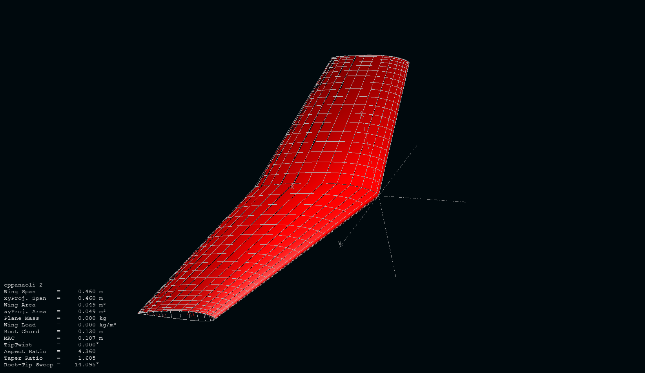

Figure 18: Formation of the wing with the gridlines

* 1. **3D printing:**

3D printing or additive manufacturing is a process of making three dimensional solid objects from a digital file. The creation of a 3D printed object is achieved using additive processes. In additive process an object is created by laying down successive layers of material until the object is created. Each of these layers can be seen as a thinly sliced horizontal cross-section of the eventual object. 3D printing enables to produce complex shapes using less material than traditional manufacturing methods.

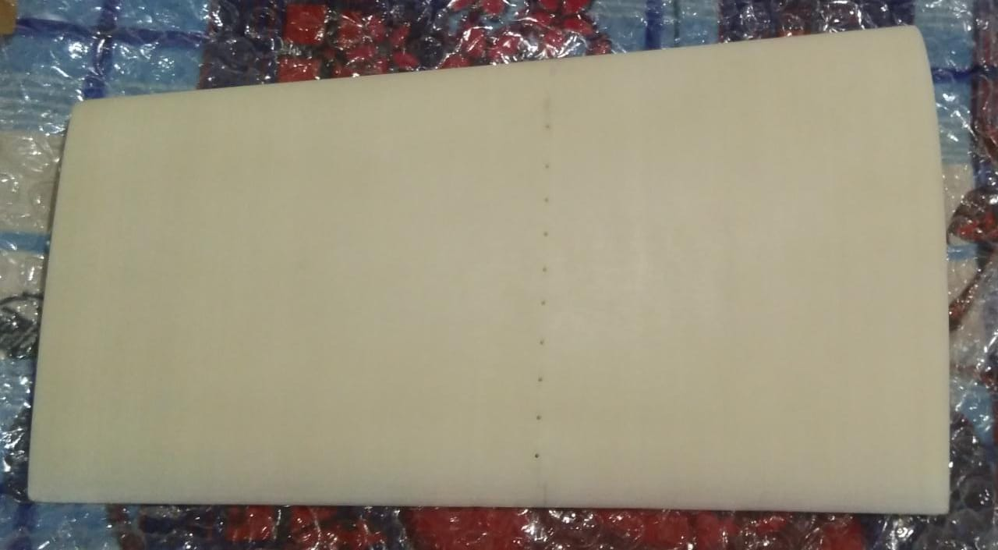

Figure 19: The fabricated canard model

The 3D printing takes place in 6 steps:

* CAD- A model is produced using computer-aided software. The software will provide some hint as to the structural integrity which can be expected in the finished product. It also provides a scientific data of how the object will behave under certain conditions.
* Conversion to STL- The CAD drawing has to be converted to STL format. The stereo lithography is a file format which is used for converting and producing the closed and connected figures for proper production of the model.
* STL file manipulation- The STL file is copied to the computer that controls the 3D printer. There the user can designate the size and orientation for printing.
* Machine setup- Each machine has its own requirements for how to prepare for a new print job. This includes refilling the polymers, binders and other consumables the printer will use. It also covers adding a tray to serve as a foundation or adding the material to build temporary water-soluble supports.
* Build- The building process is done automatically. Each layer is usually about 0.1mm thick. Depending on the object’s size, the machine and the materials used, the process could take hours or even days to complete. The machine must be periodically checked to make sure that there are no errors.
* Post processing- Many 3D printers require some amount of post processing for the printed object. This includes brushing off any remaining powder or bathing the printed object to remove water-soluble supports. The new print may be weak during this step since some material require time to cure, so caution might be necessary to ensure that it does not break or fall apart.

The model of the wing which has to be tested in the wind tunnel is fabricated with the 3d printing. The fused deposition modeling (FDM) method was used for the fabrication of the model which is an additive manufacturing technique in which the object is created directly from a computer-aided design(CAD) model using layer-by-layer deposition of a feedstock plastic filament material extruded through a nozzle. The model is made out of the Acrylonitrile Butadiene Styrene which is a common thermoplastic polymer.

* Procedure of Fused Deposition Modelling:

In the same way as other forms of 3D printing, FDM uses a digital design that is uploaded to the 3D printer. There are a lot of different polymers used, such as ABS. This takes the shape of plastic threads that are fed from a coil and through a nozzle. The filaments are melted and fed onto the base, known as a build platform or table with the base and the nozzle, both of which are controlled by a computer. The computer works by translating the object and its dimension into co-ordinates that make it possible for the nozzle and base to follow.

As the nozzle moves across the base, the plastic cools and becomes solid, forming a hard bond with the previous layer. At this point the print head goes up in order for the next layer of plastic to be laid. As always, 3D printing is efficient and fast but the time it takes to create an object does depend on its size. Smaller objects that are around several cubic inches can be created quickly but larger, more complex object will take longer.

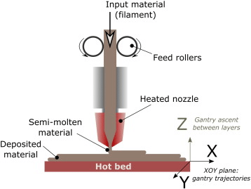

Figure 20: Fused Deposition Modelling

* 1. **Wind tunnel testing of the wing:**

The wind tunnel testing was done in a suction type subsonic speed wind tunnel with a velocity of 20 m/s. The wind tunnel from KARUNYA INSTITUTE OF TECHNOLOGY AND SCIENCE was used. The dimension of the test section is about 600mm*600mm*4000 mm.

Wind tunnels are devices that enable to us to study the flow over the objects, forces acting on them and their interaction with the flow. Wind tunnels are simply hollow tubes; at one end, they have powerful fans that create a flow of air inside the tunnel. Some tunnels are desktop-sized and good for testing only small objects.

Other tunnels are massive structures in which engineers test full-size aircraft. The test materials usually remain stationary, and the air flows rapidly over the object. Typically, there are sensors and instruments inside wind tunnels that give scientists hard data regarding the interaction of the object with wind. And often, there are windows that let the observer observe the experiments visually. With those data, the variables of aerodynamics such as pressure, velocity, temperature and density can be grappled.

The wing with NACA 2412 airfoil which was fabricated with the 3D printing method was fitted in the wind tunnel with the required fixtures. A wood piece was fixed and it was drilled for the proper fixture inside the wind tunnel. The velocity was set to 20m/s. The rpm of the wind tunnel is set to 700 to achieve the particular velocity. The pressure taps were made in the wing as per the formulae with 28 ports all along the wing.

* The measurement of pressure distribution over the wing:

The pressure ports which were placed in the wing according to the formula and accordingly 28 ports were placed and each port was connected to the different ports of the U-Tube manometer and the pressure over the wing was calculated.

Procedure:

1. Using the barometer and thermometer in the laboratory determine the density of the air flowing in the wind tunnel.
2. With the fixtures available, place the wing in the wind tunnel with the angle measurement available which is visible from out of the wind tunnel.
3. Connect the tubes which are placed in the pressure ports to the different connections of the U- Tube manometer. Check the condition and level of the U-Tube manometer before starting the wind tunnel. The static pressure of the test section is connected to the reference connection of the U-Tube manometer. The dynamic pressure of the airstream is connected to the various ports of the U-Tube manometer is noted down.
4. The rpm of the wind tunnel is set to 700 and hence the velocity of 20m/s is achieved.
5. The wing is first set at o0 angle of attack and the measurements are checked. Then the pressures are noted down and with the provision available the angles of attack are varied and the pressure variations at various angles of attack are noted down. The angles at which the readings were taken are -4o, -2o ,0o ,2o , 4o , 6o , 8o , 10o , 10o and 140.
6. Always check the zero velocity pressure measurements from the wing and the manometer before each data set. If any offsets are there it has to be corrected in the manometer at zero velocity.
7. With the pressure values obtained the center of pressure value is calculated.

With the pressure distribution over the wing, various performance characteristics can be obtained such as:

1. Centre of pressure:

The center of pressure is the point where the total sum of a pressure field acts on a body, causing a force to act through that point.

1. Coefficient of lift:

The coefficient of lift is a dimensionless coefficient which relates the lift generated by a lifting body to the fluid density around the body, the fluid velocity and an associated reference area. It expresses the ratio between the lift to the force produced by the dynamic pressure times the area.

1. Coefficient of drag:

The coefficient of drag is a dimensionless quantity that is used to quantify the drag or resistance of an object in a fluid environment, which is used to indicate the amount of aerodynamic drag.

1. Stalling angle:

The stalling angle is the angle at which the aircraft stalls. Increasing the angle of attack beyond the stalling angle the aircraft will not be able to generate lift anymore because of the flow separation which takes place at these higher angles of attack.

1. The maximum coefficient of lift:

It is the maximum value of the lift coefficient where the lift increase with the angle of attack. Beyond Cl max, the aircraft will stall.

1. Aerodynamic center:

The aerodynamic center is the point at which the pitching moment coefficient for the airfoil does not vary with lift coefficient (i.e. angle of attack)

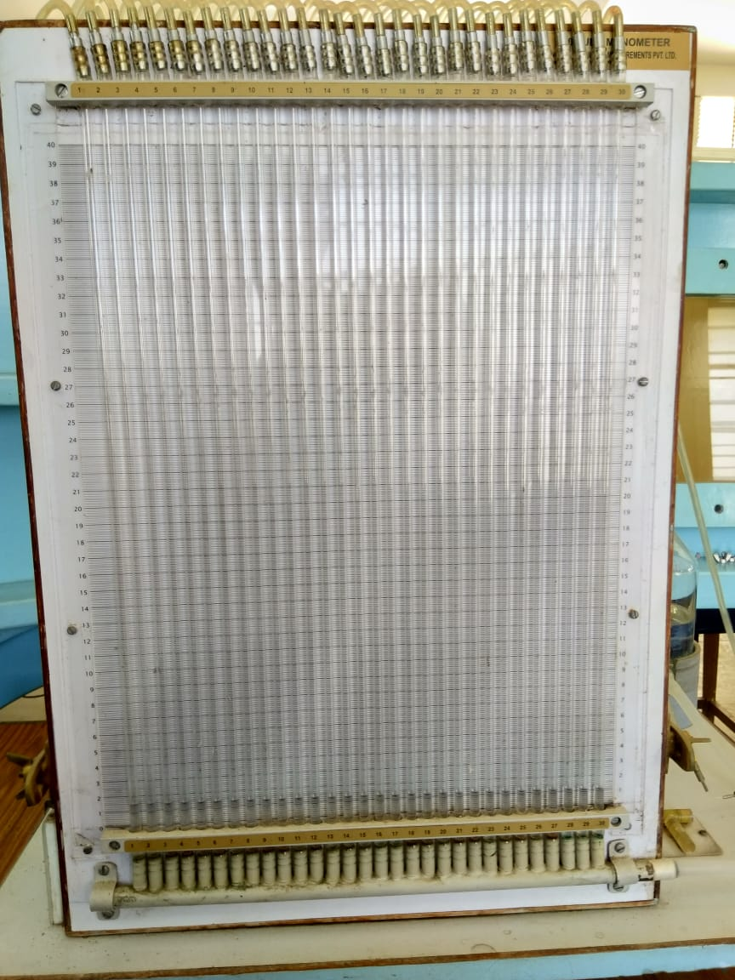

Figure 21: U-Tube manometer

* 1. **Flow visualization over the wing:**

Flow visualization techniques are used to provide diagnostic information about the flow over the model. Normally smoke is used to visualize the visualize the flow over the model. The smoke is generated with the help of smoke generators which uses borosil which is heated to produce smoke in the tunnel. Normally the blower section of the wind tunnel is used for the flow visualization.

The smoke produced is used to visualize the flow that is away from the surface of the model. Smoke can be used to detect vortices and regions of separated flow. The flow over the wing is visualized at different angles of attack. In addition to the smoke, lasers are also provided for the better view of the flow variation of the wing.

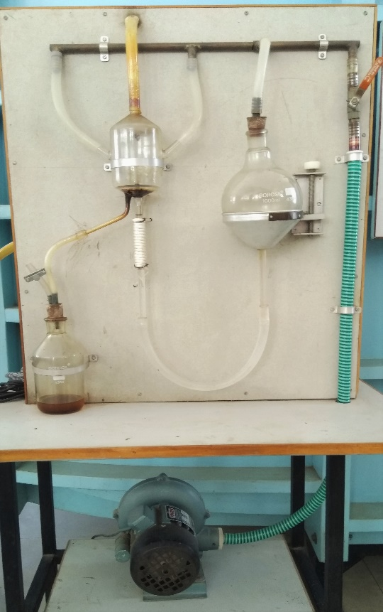

Figure 22: Smoke generators

Hence the flow over the wing is visualized with the help of smoke generators and also the flow is further made clear with the help of projecting the laser over the wing.

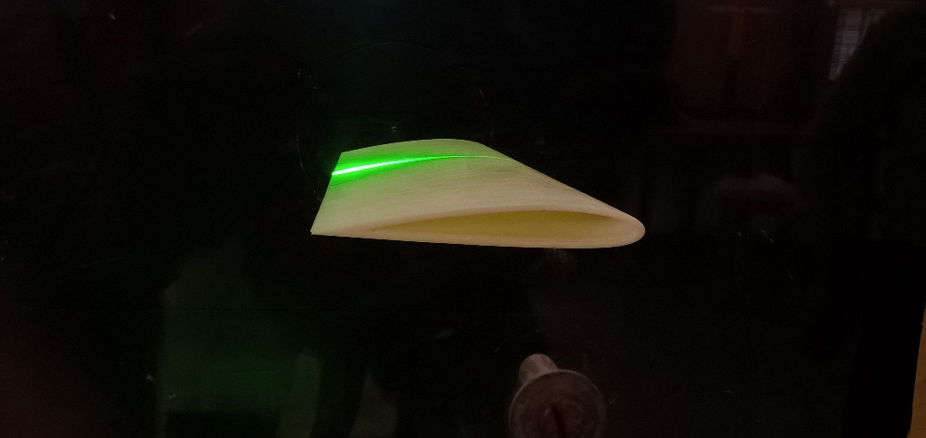

Figure 23: Placed wing model in the tunnel with laser

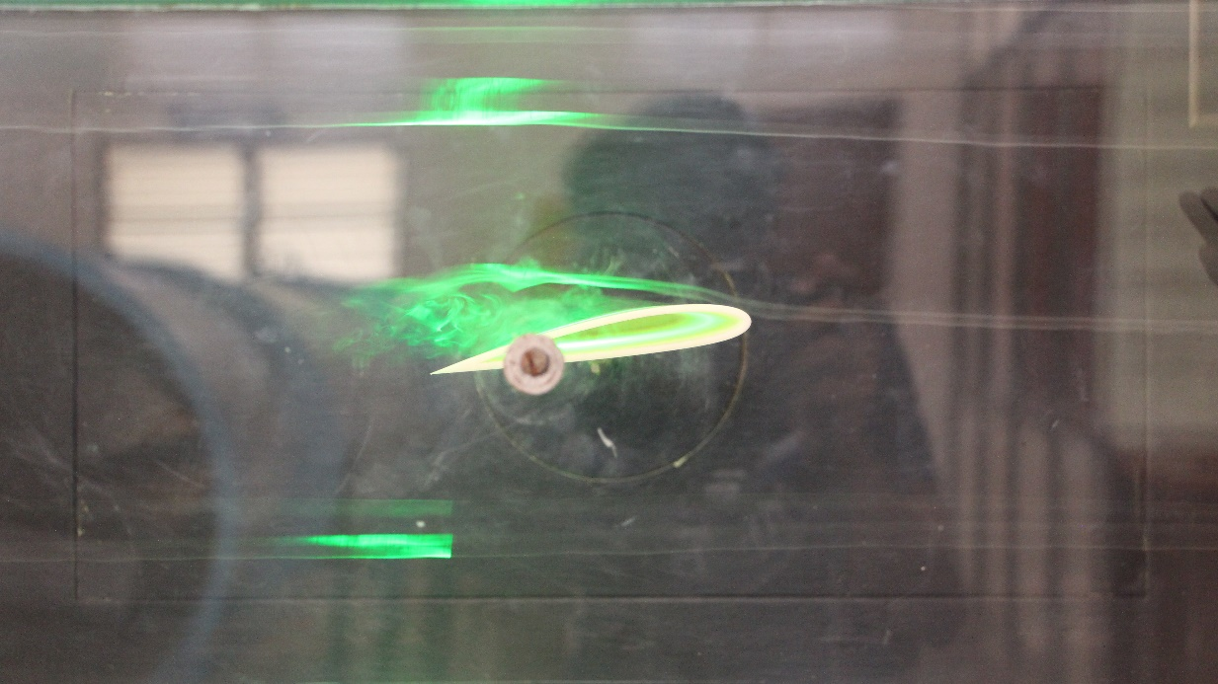

Figure 24: Flow over the wing at 4o

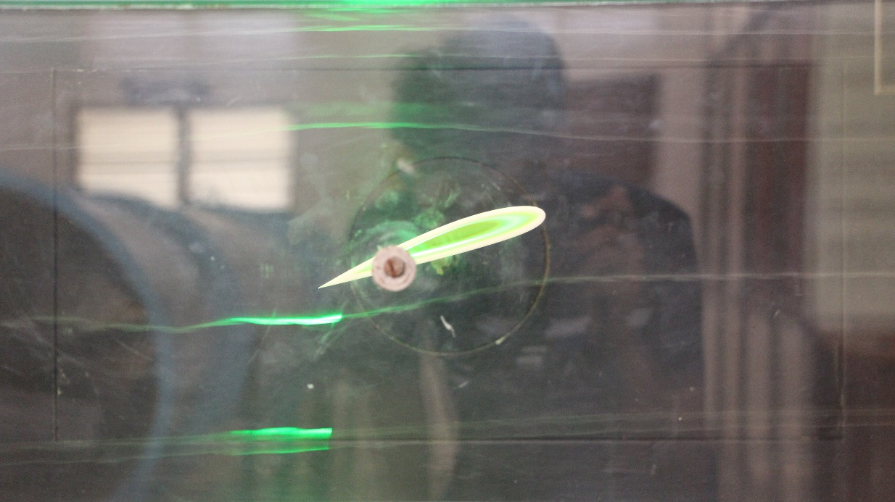

Figure 25: Flow over the wing at 14o

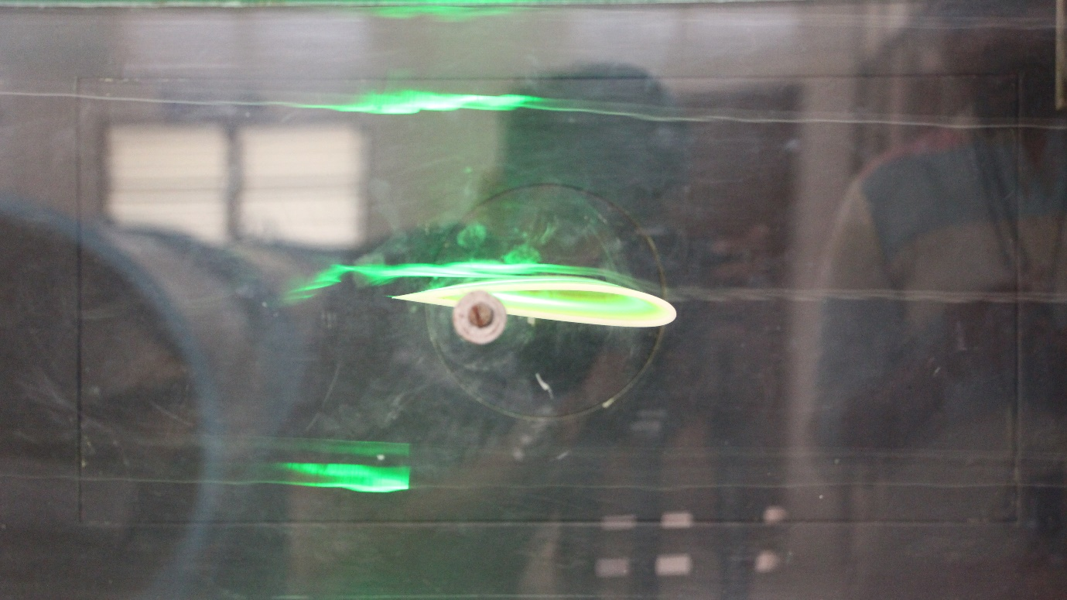

Figure 26: Flow over the wing at -4o

**4.7 Calculation of various parameters:**

Formulae used:

1. Coefficient of pressure:

The coefficient of pressure is calculated with the formula 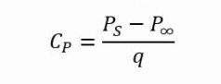

Where PS is the static pressure

P**∞ is the total pressure**

Q is the dynamic pressure

1. Coefficient of lift:

The coefficient of lift is calculated with the formula

Where is pressure coefficient on lower surface

is pressure coefficient on upper surface

is leading edge location

is trailing edge location

1. Coefficient of drag:

The coefficient of drag is calculated with the formula =

Where is the coefficient of drag

is coefficient of drag at zero lift

is coefficient of lift

e is the Oswald efﬁciency factor

AR is the aspect ratio

e = 1.78(1-0.045 AR 0.68) – 0.64

1. Aerodynamic center:

The aerodynamic center of the wind is calculated with the formula

AD =

Where AD is the aerodynamic center

c is the mean chord of the wing

1. Lift:

The lift generated by the wing is calculated with the formula

L = ρ v2 S CL

Where L is the lift generated by the wing

ρ is the density of air

v is the freestream velocity

S is the area of the wing

CL is the coefficient of lift

1. Drag:

The drag produced by the wing is calculated with the formula

D = ρ v2 S CD

Where D is the drag produced by the wing

ρ is the density of air

v is the freestream velocity

S is the area of the wing

CD is the coefficient of drag

**4.7 Comparison of the experimental values with the practical values:**

VALUES OBTAINED FROM THE WIND TUNNEL TESTING:

1. Coefficient of Lift obtained:

|  |  |
| --- | --- |
| AOA | Cl |
| -4 | -0.410 |
| -2 | -0.240 |
| 0 | -0.057 |
| 2 | 0.094 |
| 4 | 0.259 |
| 6 | 0.490 |
| 8 | 0.618 |
| 10 | 0.782 |
| 12 | 0.848 |
| 14 | 0.717 |

1. Coefficient of drag obtained:

|  |  |
| --- | --- |
| AOA | Cd |
| -4 | 0.037 |
| -2 | 0.032 |
| 0 | 0.023 |
| 2 | 0.020 |
| 4 | 0.025 |
| 6 | 0.029 |
| 8 | 0.039 |
| 10 | 0.063 |
| 12 | 0.086 |
| 14 | 0.208 |
|  |  |

1. Coefficient of lift vs alpha (angle of attack) graph:
2. Coefficient of drag vs alpha (angle of attack) graph:
3. Stalling angle of attack:

From the Cl vs alpha curve, it was found that the coefficient of lift starts reducing from 12o , therefore

Stalling angle of attack = 12o

Comparison result:

By comparing the values obtained from the XFLR5 analysis report and the values obtained from the calculations with the data obtained from the wind tunnel, about 30% variations were there in the values obtained.

* 1. **Fabrication of the canard wing aircraft model:**

The aircraft model with a canard wing is fabricated with the help of a depron and vinyl sheet. The original dimensions of the model are scaled down to 50% and the dimensions are taken. The airfoil NACA 2412 is used.

Dimensions used for the fabrication of the model:

1. Canard wing:

Area – 6860 sq.mm

Root chord – 147mm

Tip chord – 98mm

Mean chord – 122.5mm

Span – 1050.3mm

Airfoil used – NACA 2412

The thickness of the wing – 3mm

1. Main wing:

Area – 22120 sq.mm

Root chord – 260mm

Tip chord – 160mm

Mean chord – 210mm

Airfoil used – NACA 2412

Span – 5600mm

1. Size of the fuselage – 680mm*100mm

**CHAPTER 5**

**RESULT, CONCLUSION AND SCOPE OF STUDY**

**5.1 Result:**

After a lot of planning, testing and fabrication; the output obtained was the sophisticated model of a canard wing model involving the various performance characteristics which was calculated with the values obtained from the wind tunnel testing.

A lot of methods such as 3D printing, CATIA and XFLR5 were used to achieve the required result and value required.

At the end of the project the practical variation of various parameters from the theoretically calculated values was clearly understood.

**5.2 Conclusion:**

A model of canard wing has been made in the best possible way and the viewers will be able to look through and understand it better and understand the various performance characteristics involved with the canard wing. One will be also able to understand the working of the wind tunnel and the flow over the canard and hence can relate it with the practical application of the canard wing. The flow visualization and the pressure distribution at various angles of attack are well understood. Increased interests in the aircraft and its components and the working behind it in a practical manner and enthusiasm in the most interesting field of aeronautics is anticipated.

**5.3 Scope of study:**

Further interests in carrying out numerous new experiments and implementing new ideas to improve the performance and efficiently achieve the required lift with a much reduced drag, higher angles of attack and better maneuvering capability could all be advanced with more time and research and development in this study.

New ideas such as varying the configuration of the canard wing, location and dimensions of the canard wing further improvements can be done in the performance of the aircraft and hence betterment can be achieved in the canard configuration.

**REFERENCES:**

1. Anderson, J.D., Fundamentals of Aerodynamics, 5th edition, Tata McGraw- Hill Education,2010.
2. [www.researchgate.net/publication/304545693_Calculation_of_Aerodynamic_Performance_Characteristics_of_Airplane_Wing_and_Comparing_with_the_Experimental_Measurement](http://www.researchgate.net/publication/304545693_Calculation_of_Aerodynamic_Performance_Characteristics_of_Airplane_Wing_and_Comparing_with_the_Experimental_Measurement)
3. Anderson J.D., Computational Fluid Dynamics, McGraw Hill, 1995
4. Anderson J.D., Introduction to Flight, McGraw-Hill, 6th edition,2008
5. Rutan Aircraft Factory, Long-EZ – Owner’s Manual, 2nd edition, 1981
6. NASA TP-2382, Wind-Tunnel Investigation of a Full-Scale Canard-Configured General Aviation Airplane, Yip, Long P, 1985
7. <http://www.researchgate.net/publication/280757155>
8. David Communier, Aero Structural Modelling of a Wing using CATIA V5 and XFLR5 Software and Experimental Validation using the wind tunnel, Montreal, 2004
9. Patel, Karna S., CFD Analysis of an Aerofoil, International Journal of Engineering Research 3.3, 2014
10. Elsevier, Appendix 2: Design of canard aircraft, 2013